DEVELOP A WEB APPLICATION USING NODE-RED SERVICE

|  |  |
| --- | --- |
| Date | 19 November 2022 |
| Team ID | PNT2022TMID37952 |
| Project Name | Project - IoT Based Safety Gadget for Child Safety Monitoring and Notification |

DEVELOP A WEB APPLICATION USING NODE-RED SERVICE:

1. The node red application is developed with the required function.

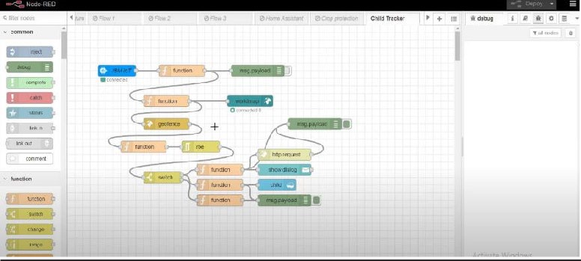

1. Python code:

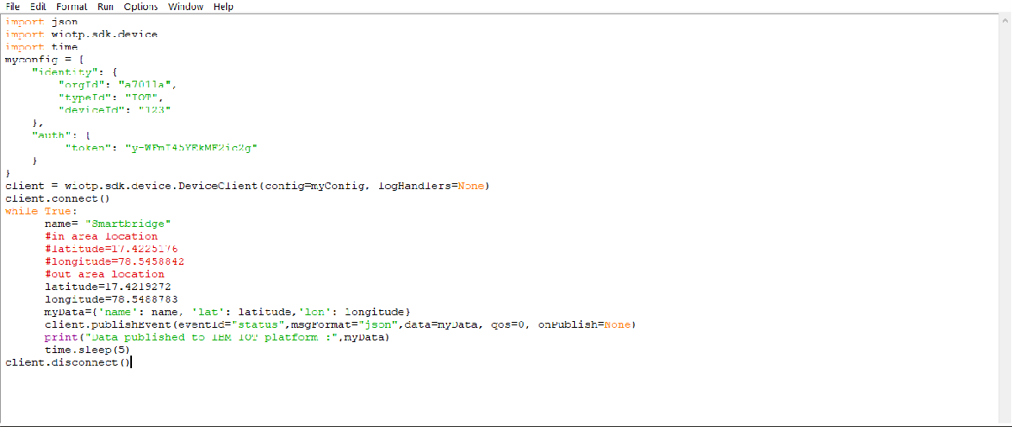

1. Create a geofence

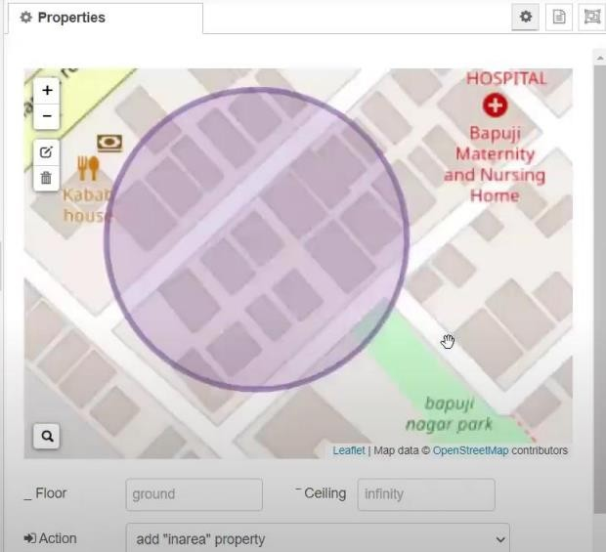

1. Edit the http request url.

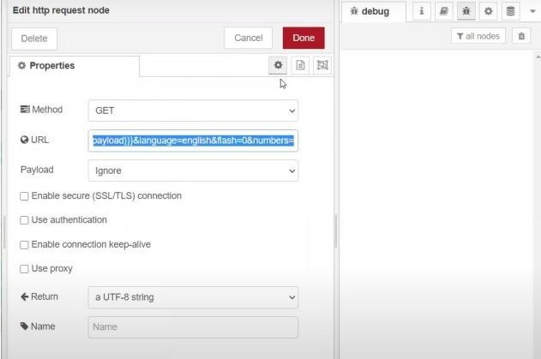

1. Locate the child.

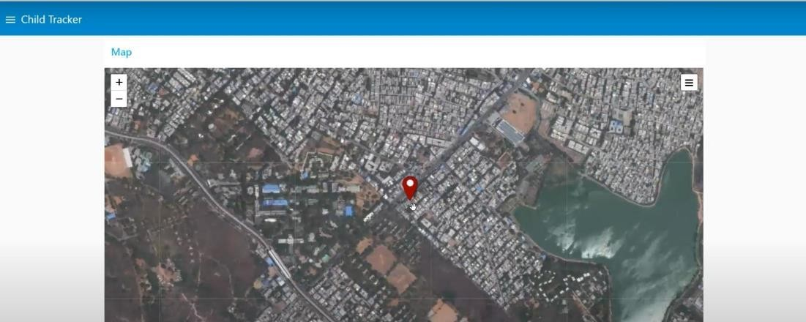

1. Create the geofence node.

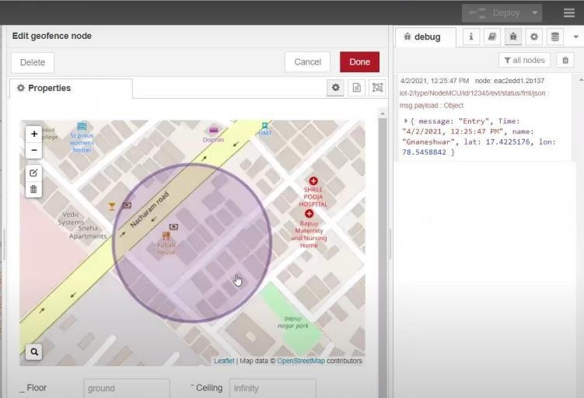

1. Python script send requests to IBM cloud:

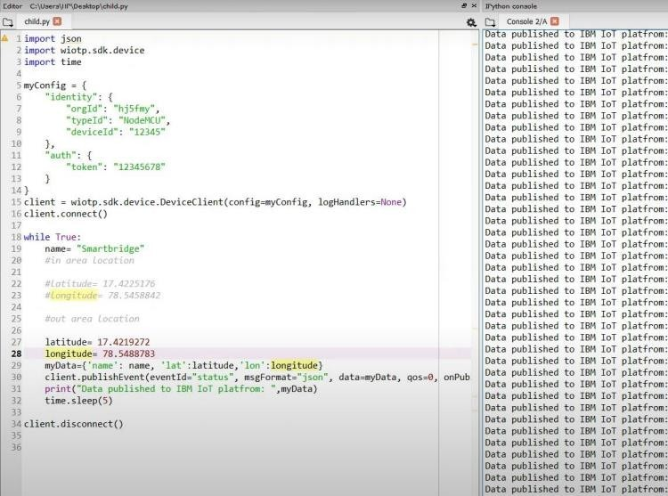

1. The web application is developed.

